Wesleyan University shield]

http://www.aacu.org/

http://www.aauw.org/

http://www.wesleyan.edu/partnerships/

http://www.aps.org/programs/women/workshops/gender-equity/index.cfm

Campus Climate Discussion:

Fostering Equity and Inclusion of Females Physics Students

February 26, 2014 (revised 8/25/14)

12 PM – 1 PM

Exley Science Center, Wesleyan University

Introduction

Review of Community Learning Guidelines

Reflection on Individual Learning Outcomes

Activity: “How am I (based on my gender expression) perceived?” and “How do I perceive myself?” (page 2)

Cycle of Socialization (page 3)

Gender Discrimination at Job Interview <http://www.youtube.com/watch?v=Eb-AqnwOTxE>

Key concepts and terms (page 4)

Federal Laws that protect against discrimination based on sex <http://www.eeoc.gov/facts/qanda.html>

Wesleyan University Information about Title IX

[http://www.wesleyan.edu/inclusion](http://www.wesleyan.edu/affirm/discrimination_harassment_policy.html)

For more information, please contact the Wesleyan University Office of Equity & Inclusion:

Antonio Farias, VP for Equity & Inclusion/ Title IX Officer

(office) 860.685.3927 (e-mail) afarias_at_wesleyan.edu

Debbie Colucci, Equity Compliance Director and Deputy Title IX Coordinator  
(office) 860.685.2456 (e-mail) dcolucci_at_wesleyan.edu

Renee Johnson-Thornton, Dean for Equity & Inclusion

(office) 860.685.2272 (e-mail) rjohnson01_at_wesleyan.edu

Trisha Stephenson Gordon, Affirmative Action Specialist  
(office) 860.685.4771 (e-mail) pblount_at_wesleyan.edu

“How am I (based on my gender expression) perceived?” and “How do I perceive myself?”

On the left side of this page, write down how you have come to perceive/understand your gendered identity. On the right side of this page, write down how others often incorrectly perceive you, stereotype you, or feel about you as a member of this gendered group.

How I Perceive Myself How Others Often View Me

Reflection Questions:

1. How did this exercise make you feel? Why do you think that is?
2. What were some similarities that you found in each others’ stories?
3. What were the differences?
4. What do you notice about these differences?
5. Where do you think stereotypes or misperceptions about social groups come from?

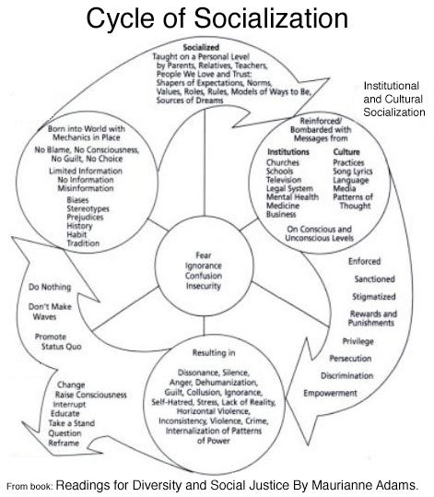

Key concepts and terms:

1. Sexual objectification. Objectification encompasses behaviors ranging from using innuendos to catcalling to sexual violence. When women are referred to as “hotties” or as body parts, they are being objectified. Campus events such as date auctions are an example of objectification.
2. Second-class citizenship. Whether they are in the classroom, on the playing field, or in extracurricular settings, women may receive messages that they should not have the same privileges or opportunities as men. (A student I interviewed for a qualitative study of a campus feminist group alluded to these messages when she said she believed the university was “more responsive [to] men” (Vaccaro 2009).)
3. Assumptions of inferiority. Although it is uncommon to hear such beliefs stated overtly, some people assume that women students are less capable than men in a variety of arenas, whether physical, academic, or emotional. In the physical arena, assumptions of inferiority may cause women to be excluded from formal or informal sports. In the academic arena, some women may be discouraged from majoring in science, math, or other traditionally male-dominated fields. And in the emotional arena, women may be viewed as too sensitive or weak.
4. Assumptions of traditional gender roles. Even in the twenty-first century, people tend to praise women for engaging in domestic tasks such as decorating for homecoming weekend, cleaning up after extracurricular events, or cooking for roommates. Women students may also be expected to enact “feminine” behaviors, such as caring for others or displaying “proper” demeanors. When women’s behaviors diverge from these expectations, peers, faculty, and staff may respond negatively.
5. Use of sexist language. Demeaning terms used to describe women can be commonplace on campus. Women may hear peers, campus performers, and even faculty and staff use offensive terminology to describe women.
6. Denial of the reality of sexism. When people downplay women's oppression, they can make the phenomenon invisible and perpetuate the cycle of sexism. Examples include citing women's achievements in education as evidence that the climate is no longer chilly or telling a woman that she is being “too sensitive” about oppression.
7. Men’s denial of individual sexism. Individual men contribute to chilly climates when they refuse to acknowledge their own sexist behaviors. Denial can include refusing to admit that a joke, belief, or comment is sexist.
8. Environmental microaggressions. These systemic microaggressions are messages in the social and cultural environment that communicate to women that they are inferior or less deserving. Environmental microaggressions are similar in form to what feminists refer to as institutional sexism (Risman 2004), which includes structural concerns such as the invisibility of women’s issues in curricula, the exclusion of women from leadership roles, or the lack of programs or services designed for women.

Research has highlighted many negative consequences of microaggressions, including increased stress, depression, anger, rage, and hopelessness (Sue 2010). With these effects, it is no surprise that microaggressions can also result in chilly campus climates for women.

**Vaccaro, A. (2010). Still chilly in 2010: Campus climates for women. AAC&U On Campus with Women 39(2) Retrieved February 25, 2014 from http://www.aacu.org/ocww/volume39_2/feature.cfm?section=1**